# Practical 2

# Create OLTP System for Ticket Reservation

BID_Practical2.py

import csv

from flask import Flask, render_template, request

app=Flask(__name__)

app.secret_key='12345'

@app.route('/')

def webpage():

return render_template('form.html')

@app.route('/process',methods=['POST'])

def process():

fname=request.form['fname']

lname=request.form['lname']

noOfPeople=request.form['noOfPeople']

seatType=request.form['seatType']

with open('bid2.csv', 'a') as csvfile:

csv_writer= csv.writer(csvfile)

#csv_writer.writerow(['Firstname','Lastname','No Of People','Seat Type'])

csv_writer.writerow([fname,lname,noOfPeople,seatType])

return 'Records Inserted'

if __name__=='__main__':

app.run(debug=True)

Form.html

<!DOCTYPE html>

<html lang="en">

<head>

<meta charset="UTF-8">

<meta name="viewport" content="width=device-width, initial-scale=1.0">

<meta http-equiv="X-UA-Compatible" content="ie=edge">

<title>Document</title>

</head>

<body>

<form method="POST" action="/process">

<div class="form-group">

<label for="exampleInputFName">Enter First Name</label>

<input type="text" class="form-control" id="exampleInputFName" placeholder="Enter First Name" name="fname" value="{{request.form.fname}}">

</div>

<div class="form-group">

<label for="exampleLInputFName">Enter Last Name</label>

<input type="text" class="form-control" id="exampleLInputFName" placeholder="Enter Last Name" name="lname">

</div>

<div class="form-group">

<label for="examplePeople">Enter No of People</label>

<input type="number" class="form-control" id="examplePeople" placeholder="Enter No of People" name="noOfPeople">

</div>

<div class="form-group">

<label for="exampleType">Enter Seat Type</label>

<input type="text" class="form-control" id="exampleType" aria-describedby="seatHelp" placeholder="Enter Seat Type" name="seatType">

<small id="seatHelp" class="form-text text-muted">Enter D for Diamond , Enter G for Gold , Enter S for Silver.</small>

</div>

<button type="submit" class="btn btn-primary">Submit</button>

</form>

</body>

</html>

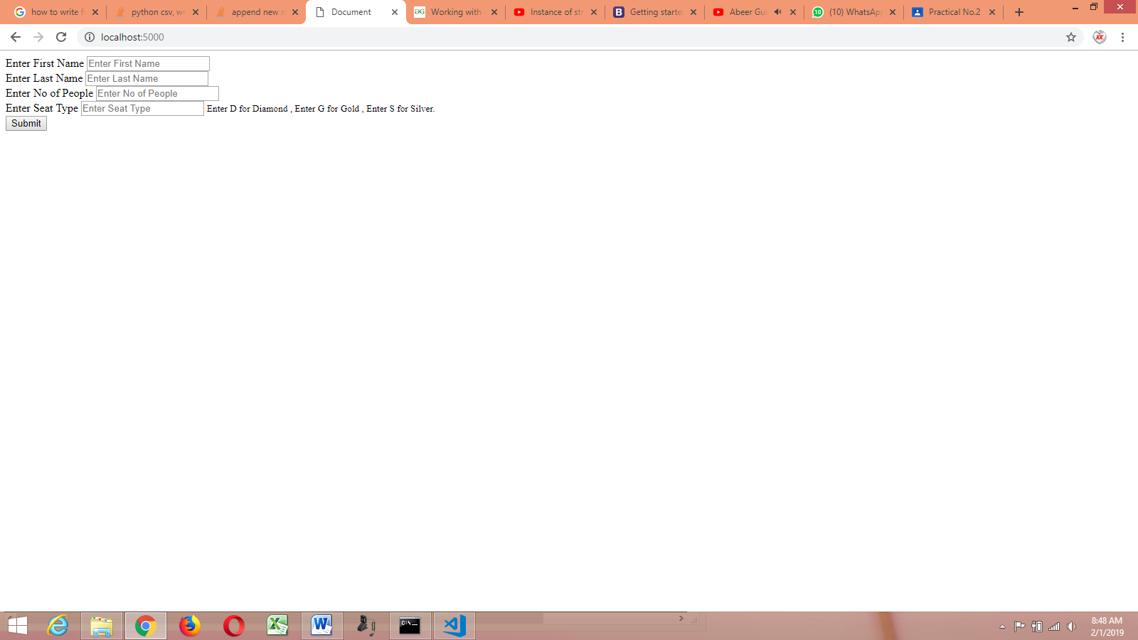

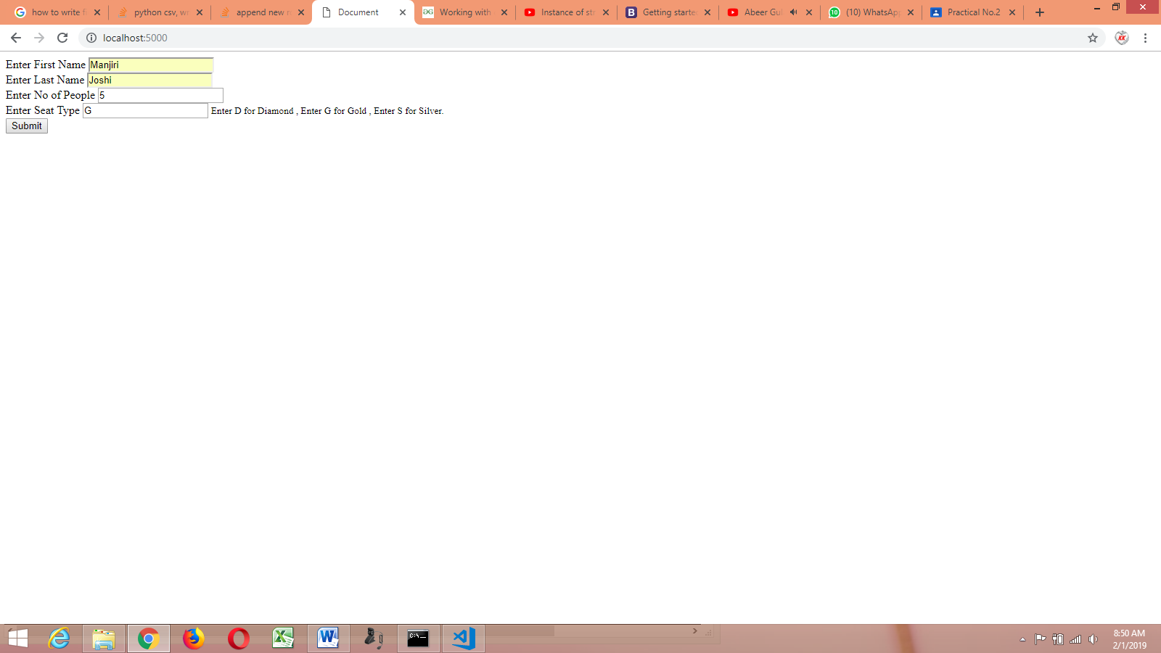



Bid2.csv

